### *Websites are a magnet for judgement*: If anyone had wondered how many websites there were back in 1995, the answer would have been just 23,500. The number of websites in the world today is estimated at around 1.72 billion. It takes  about 0.05 seconds for users to form an opinion about a website that determines whether they like your site or not, whether they’ll stay or leave. It takes [2.6 seconds](https://conversionxl.com/blog/first-impressions-matter-the-importance-of-great-visual-design/) for a user’s eyes to land on the area of a website that most influences their first impression. [88%](https://www.invisionapp.com/inside-design/statistics-on-user-experience/) of online consumers are less likely to return to a site after a bad experience. What does it all mean?

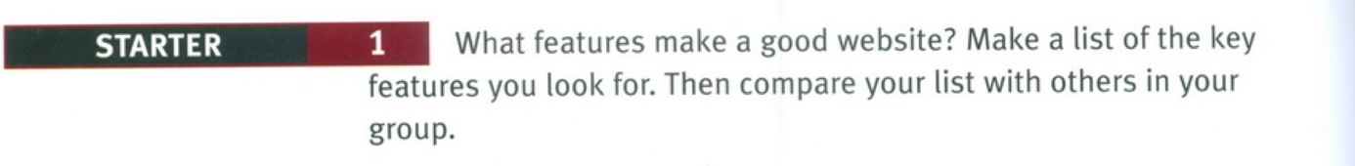

**2. Imagine you have to conduct a website audit for a website of your choice. Study the following** [**“10 Usability Heuristics for User Interface Design”**](https://media.nngroup.com/media/articles/attachments/Heuristic_Summary1-compressed.pdf) **(Nielsen’s 10 general principles for user interaction design) then select a website and evaluate it against some of the rules of thumb included in Nielsen’s heuristics.**

[**https://media.nngroup.com/media/articles/attachments/Heuristic_Summary1-compressed.pdf**](https://media.nngroup.com/media/articles/attachments/Heuristic_Summary1-compressed.pdf)

Listening practice

**3. a) Watch the following video and 1) suggest a descriptive title for the video and 2) summarize the information from the video in one sentence.**

<https://youtu.be/9BHOolQyi1k>

**4. b) In the video, click-counting by itself is not presented as a meaningful metric for designing website IA and navigation. Watch the audio again and report the important ideas associated with practices for good navigation.**

1.

2.

3.

**5. Take a look at the following screenshot taken from the homepage of the Official Website of the City of New York. The diagram shows that any user can report a broken water meter in only 3 clicks.**

**Explain how this works and comment on the use of the 3-click rule.**

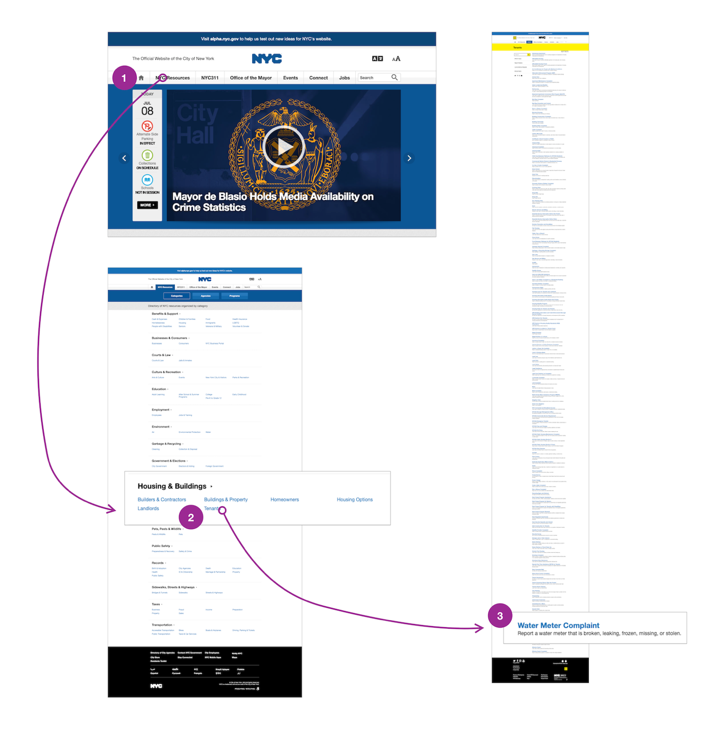

### II. Reporting - paraphrase, summary & plagiarism

**Considerations for writing a formal summary/paraphrasing\***

( a summary is shorter than the original, whereas a paraphrase is approximately the same length)

**Paraphrasing** and **Summarising** skills can help you in your studies for different purposes such as

⮚ preparing for exams  
⮚ taking notes on your readings  
⮚ collecting and condensing information for writing research papers  
⮚ integrating sources into your writing

**Paraphrasing** is an important skill to use while supporting your ideas. Paraphrasing is writing the ideas of another person (usually an authority) in your own words, without changing the meaning.

**Steps for writing an effective paraphrase:**

1. Read and understand the text.

2. Change the words/phrases with their **synonyms** (you might consider possible **synonyms for the source vocabulary** and **changing the part of speech** (change nouns to verbs, adjectives to adverbs, etc.)

* Do **not** try paraphrase **specialized vocabulary** or technical terms.
* You can **borrow** **standard phraseology** of your field and skeletal phrases when appropriate, but not special expressions or phrases in their entirety without at least using quotations marks.

Eg. *The increasing popularity of _________is attributed to_________.* The increasing popularity of Voice over Internet Protocol can be attributed to its low cost.

3. **Change the structure** of the original text (break up long sentences, combine short sentences, for instance).

4. **Rewrite** the original in your own words to avoid plagiarising.

5. Keep the text at approximately the same **length** as the original.

6. Keep the **meaning** as it is.

7. Remember to give **in-text reference**.

**Steps for writing an effective summary:**

1. Read the text carefully and make sure you fully understand the text.

2. Identify the **central idea** and all the **main ideas**. Distinguish between main and subsidiary information.

3. Leave out **minor details, examples, illustrations or explanations**.

4. Keep the most important information that accurately represents all the major points of the original text.

5. **Paraphrase** the original text accurately in your own style by **preserving the original meaning** of the text.

6. Do **not** include any **personal opinions**, interpretations, deductions or comments unless you plan to do a critical review. Keep the **text shorter** **than the original** text (about 1/3 or 1⁄4 of the original). Respect the **order of the ideas** presented by the writer. Present the important points by focusing on **old-to-new information flow**.

7. Make sure the ideas flow logically by meaningfully combining the sentences with the help of **transitions**.

8. Remember to give **in-text reference**.

9. Check **clarity** and **conciseness** of the summary for a reader who has not seen the original text.

**Plagiarism**

**1. Study the following examples of an original text vs a plagiarised version, draw a comparison between the two text samples and formulate appropriate comments:**

|  |  |
| --- | --- |
| Original | Plagiarised version |
| "How important is our power of nonanalytical thought to the practice of science? It's the most important thing we have, declares the Princeton physicist historian Thomas Kuhn who argues that major breakthroughs occur only after scientists finally concede that certain physical phenomena cannot be explained by extending the logic of old theories. Consider the belief that the sun and the planets move around the earth, which reigned prior to 1500. This idea served nicely for a number of centuries, but then became too cumbersome to describe the motions of heavenly bodies. So the Polish astronomer Copernicus invented a new reality that was based on a totally different `paradigm' or model--that the earth and planets move around the sun" (Hoover, 124). | Non-analytic thought is considered very important to the practice of science by Princeton physicist historian Thomas Kuhn who claims that major breakthroughs happen only when scientists finally concede that some physical phenomena defy explanation by extending the logic of old theories. One idea which served nicely for many centuries but then became too cumbersome was the belief that the sun and planets revolved around the earth. This was held prior to 1500 until Copernicus invented a new reality: the earth and planets move around the sun. |

Taken from Cough (2000), *Plagiarism in natural and programming languages: an overview of current tools and technologies*, <https://ir.shef.ac.uk/cloughie/papers/plagiarism2000.pdf>.

***Why is this plagiarism?***

The writer has used Hoover's exact words without enclosing them in quotation marks. The lack of quotation marks, reference and repeated use of exact wording and sentence structure that make this plagiarism S/he has only substituted synonyms here and there. Even though Hoover is credited with a citation, this would be considered plagiarism.

**2. Also compare the following sample texts and identify: (a) the original text (b) the paraphrase (c) plagiarism**

|  |  |
| --- | --- |
| The creation of an overall design for a complete computer system is the responsibility of a systems analyst; whereas, the implementation of the design plan is often the duty of the computer programmer. | The systems analyst designs the entire computer system, and the computer programmer makes the proposed system work. |

**4. Paraphrase the following paragraph using *because/lead to or due to*. Before writing, break the task into important points, relationships, linking phrases and connectors, and synonyms.**

. . . nondriving-related *devices,* such as mobile phones, and, more recently, navigation systems, divert drivers' attention increasingly more away from the primary sources of information necessary for safe operation of the vehicle: the road and other road users.

**5. Work in groups and summarise the advice in each text in one sentence. Include the sentences in the table below.**

Group A reads texts 1 to 3.

Group B reads texts 4 to 6.

Group C reads texts 7 to 9.

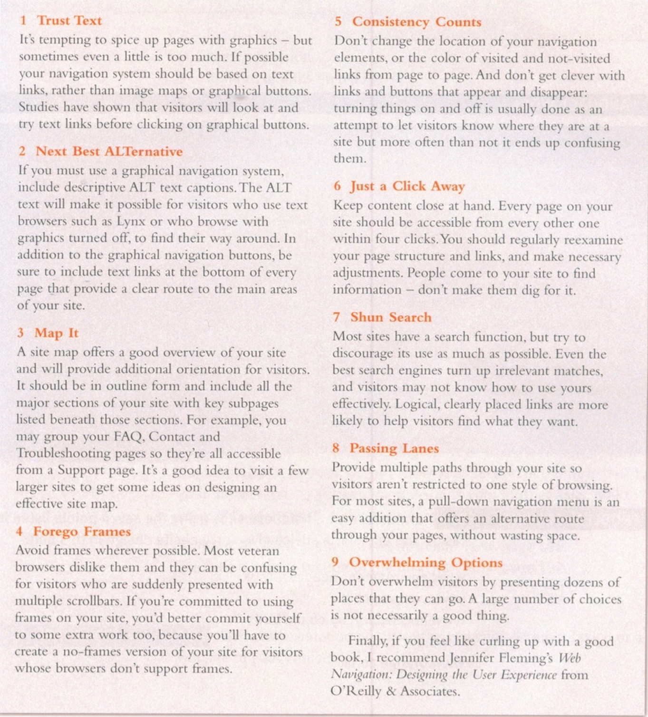

**Complete this table summarising the whole text:**

|  |  |
| --- | --- |
| *Text* | *Advice* |
| *1.* |  |
| *2.* |  |
| *3.* |  |
| *4.* |  |
| *5.* |  |
| *6.* |  |
| *7.* |  |
| *8.* |  |
| *9.* |  |